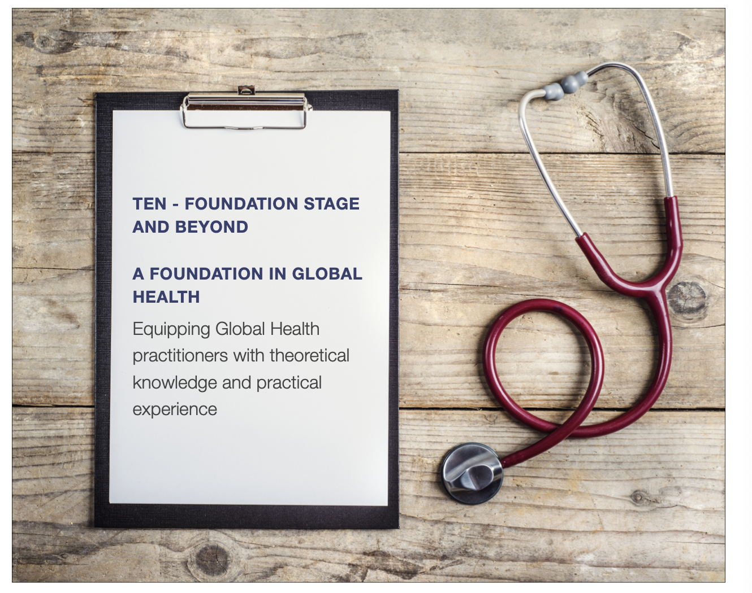

Programme Leads:
Alexa Cunningham (alexa.cunningham@electives.net)
Lyndall Hall (lyndall.hall@electives.net)
Programme Coordinator:
Yasmin Jay (yas.jay@electives.net)
Telephone: 07479541119

A Foundation in Global Health:

A Free Course offered to Foundation Doctors in all UK Trusts; developed by TEN, funded through an educational grant from Medical Protection.

Introduction:

This September we are excited to be launching our online course called "A Foundation in Global Health" for Junior Doctors in the UK who are starting their Foundation Year 1 and 2 training. This course aims to provide theoretical knowledge and practical experience in Global Health, equipping Junior Doctors with the skills and competencies necessary to engage in effective Global Health work. The course will be delivered by leading Global Health experts, medical professionals, and academics. The Electives Network has extensive global connections with healthcare organisations, NGOs and institutions offering elective placements, opportunities and resources for healthcare professionals and students who are interested in Global Health.

Course Details:

The course will be divided into two modules, one taught during FY1 and the other during FY2, with each module lasting ten weeks. The inaugural course will run from September 2023 until April 2025.

The first year of the course will be offered online with live lectures taking place in two, five-week blocks. The first lecture will commence on the 28th of September at 1pm and end on the week commencing the 30th of October. The Second will run from the w/c 29th of January until the w/c 4th of February. Each week on Thursday at 1pm the session will include a 45-minute lecture, followed by a 15-minute Q&A discussion, delivered online. Students will be able to access the lecture recordings after each session. Teaching will be supplemented by reading lists for each week and interactive multiple-choice questions and quizzes on the platform.

Teaching Format:

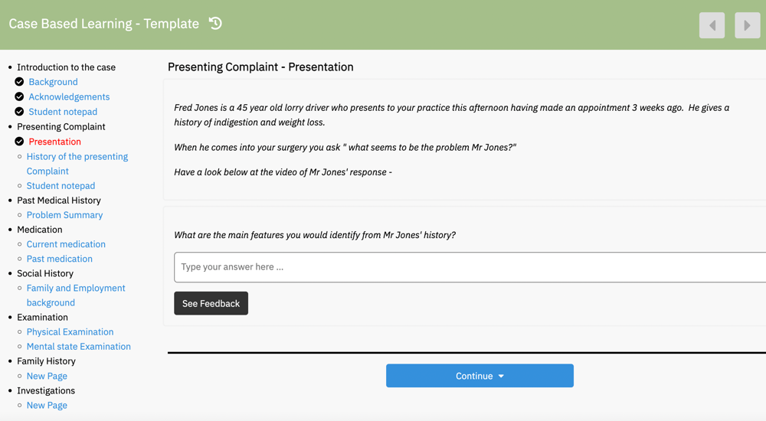
The course will utilize online lectures, interactive discussions, and a hands-on learning experiences to provide a comprehensive understanding of key Global Health topics.The course will be taught via the platform Causeway, hosted on The Electives Network website.
Lecture recordings will be uploaded to the platform each week along with reading list, supporting documents and short assessments to assess understanding and engagement. If students are unable to attend the live lectures at 1pm on Thursdays, they should inform the course coordinator (yas.jay@electives.net) and will be able to access the material after the session has finished.

Speakers:
Experienced Global Health practitioners and experts in the field will teach the course, offering insights into their current research focus or Global Health projects.

Dr Chris Willott
Dr Willott is the Education Lead and Course Director of the MSc Global Health course at King’s College University. He has a PhD in International Development, investigating the Nigerian higher education sector. He has been teaching for over 17 years covering topics such as the relationship between states and societies and the discourse around development.

Dr Jemma Wright and the ICHG
Dr Wright is a Speciality Doctor in Community Paediatrics with a keen interest in Neurodisability, Paediatric Infectious Disease and Education and International Child Health. She Is on the board of the International Child Health Group, a special interest group of the Royal College of Paediatrics and Child Health that advocates for better Child Health, Education and Training around the world.

Professor Wendy Graham
Professor Graham is a Professor at the London School of Hygiene and Tropical Medicine. She set up the school’s first research group dedicated to Maternal Health and continues to be involved in research, focusing on Infection Prevention and Control in Maternity and Neonatal units in low- and middle-income countries. She is also currently the head of the Maternal and New-born Health Group in the Department of Infectious Disease Epidemiology.

Dr Jake Parnian
Jake has been working as a doctor in the NHS for 5 years and has a masters in Climate Change from KCL. With a strong passion for climate change and its effect on human health, his previous work has aimed to incorporate climate change knowledge and sustainable practices into the NHS through his teaching series delivered across South London Hospital trusts. He has a keen interest in carbon-foot printing and sustainable respiratory and renal medicine and has been an active contributor to the respiratory care team at King’s College Hospital.

Professor Fouad M. Fouad
Professor Fouad is an Associate Professor of Public Health Practice at the Faculty of Health and Science at the American University of Beirut and the Co-Director of the Refugee Health Programme at Global Health Institute. He was also a General Surgeon and Director of Primary Health Care department in Aleppo, with specialist interest in HIV/AIDS, communicable and non-communicable disease, health policy and management and tobacco control programmes.
Odein Princewill

Odein is a Researcher at the University of Leeds, who specialises in International Law and Global Governance. She is currently supporting the School of Medicine in their efforts to decolonise the curriculum. She has contributed to the research surrounding the current socio-economic order of the world.

Professor Kabir Sheik

Professor Sheik is a health policy and systems researcher, planner, practitioner, and educator, working across Asia, Africa, Europe, Australia and South America. He has worked as a Policy Advisor at the Alliance for Health Policy and Systems Research, World Health Organization, and as a Director for Research and Policy at the Public Health Foundation of India (PHFI), New Delhi. In addition, he has worked in different roles for the Governments of India and Delhi, DfID, the London School of Hygiene and Tropical Medicine (LSHTM), WHO and UNICEF.

Year One Course Outline and Learning Objectives
By the end of the course, students will be able to:
- Describe the main determinants of health (social, environmental, and commercial) and how they vary across different populations and contexts.
- Explain the global burden of disease and its distribution and identify major health challenges facing different regions of the world.
- Analyse health systems and policies in different countries and compare different models of healthcare delivery.
- Critically evaluate different approaches to addressing Global Health challenges, including prevention, treatment, and policy interventions.
- Demonstrate an understanding of cultural competence and the importance of working with local communities and stakeholders in Global Health work.
- Develop practical skills and competencies for Global Health work, including an understanding of Global Health Ethics and ability to navigate different health systems.
Course Schedule

Proposed Date
28/09/23 | Week 1 - Introduction to Global Health:
1pm | Dr Chris Willott
 | Understand key concepts and definitions in Global Health.
 | Identify major health challenges facing the world and the global burden of disease.
05/10/23 | Week 2 - Child Health:
1pm | Dr Jemma Wright
 | Looking at Global Paediatric medicine understanding key developments in the field, challenges and future targets.
12/10/23 | Week 3 - Maternal and Neonatal Health:
1pm | Professor Wendy Graham
 | Identify major challenges in maternal and neonatal health.
 | Understand existing targets and programs in maternal and neonatal health.
19/10/23 | Week 4 - Environmental health:
2pm | Dr Jake Parnian
 | Recognize environmental risks to health, including climate change and pollution.
 | Review NHS environmental targets and their impact on Global Health.
26/10/23 | Week 5- Non-Communicable Diseases:
1pm | Professor Fouad Fouad
 | Assess the burden and impact of chronic diseases
 | Explore the strategies for prevention and management of diseases like cardiovascular disease, cancer, and diabetes in a global health context
 | BREAK
01/02/24 | Week 6 – Decolonising Medicine and Health
 | Identify, understand and be able to deconstruct colonial narratives within healthcare
 | Understand the historical context and the contemporary implications of colonial narratives
08/02/24 | Week 7 – Health Systems and Policies
 | Compare and contrast different modes of healthcare delivery
 | Analyse health financing and governance in different countries
15/02/24 | Week 8 - Health determinants and inequalities:
 | Explore social, political, and economic factors influencing health.
 | Recognize the role of culture, power, and money in determining health outcomes.
22/02/24 | Week 9 - Global Health ethics:
 | Analyse ethical dilemmas in Global Health work, such as resource allocation and cultural competence.
 | Use case studies to explore ethical issues related to big pharma, organ donation, and humanitarian aid.
29/02/24 | Week 10 - Reflection and discussion session:
 | Reflect on the module content and personal learning outcomes.
 | Discuss future directions in Global Health and emerging challenges.
 | Provide guidance on how to become more actively involved in Global Health work, including ethical and sustainable placements and healthcare partnerships.

Assessment:
To receive a certificate of completion, participants will be required to fulfil the following assessment criteria:
- Reflective Report - Participants will be expected to submit a reflective report highlighting their key learnings and insights from the course.

Choose one of the topics we have covered from the course schedule and write 2,000-word blog post introducing the topic, describing the background, current situation and future projections/routes for the topic to go

Example:

Non-communicable week
What is a non-communicable disease?
Current global issues relating to non-communicable diseases – what are the most common burdens and why – maybe focus on a specific area in the world to demonstrate it
What is the approach to treating or the dealing with the issue – pros and cons of this approach
Future direction based on the pros and cons

Attendance:
Participants must achieve at least 80% attendance, by participating online and completing the designated tasks on the learning platform to demonstrate engagement.

